A Dedication to the Amazing Moms at Jaminet Engineering

Jane Sellman once said, “the phrase ‘working mother’ is redundant,” and we couldn’t agree more.
As we quickly approach Mother’s Day, we want to take a moment to appreciate the hard-working moms at Jaminet Engineering. These women continue to defy the odds and prove that it is possible to excel professionally and as a mom. They set an example in their homes, as well as in our office. Their wisdom and their drive inspire us each day. We find ourselves watching in awe as they juggle the demands of motherhood, all while excelling in their roles at the office.
Patricia Carr has been tagged as the “office mom” since she joined the team in 2007. Her organization and attention to detail keeps the day to day activities running smoothly.
Although her resume is full of accomplishments, her greatest achievement, she says, was raising her daughter, Daphne. The two have an unbreakable bond. Patricia was smiling ear to ear as she reminisced about recent memories made with her daughter.
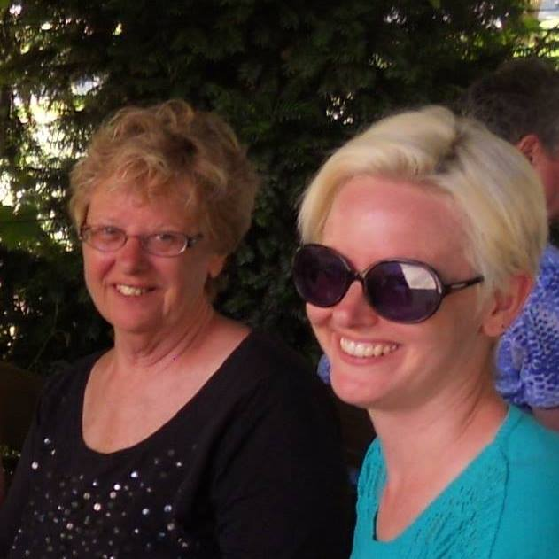
“She and I have shared so many good times together,” said Patricia. “We once went on vacation and she had rented a tree house rather than a hotel room. We sat in the middle of a beautiful forest and shared wine and cheese on the porch. This year, I was able to fulfill an item on my bucket list. We got to walk down Fifth Avenue during the Easter Parade. It was just like the old Judy Garland and Fred Astaire movie. We then had brunch at Rockefeller Center. It was a perfect day.”

As she went on about Daphne, she also took a moment to remember her own mother.
“My mom was one of those old-fashioned moms. She was a great cook and baker. She always had homemade goodies, yet all my brother and I wanted was Oreos. Now I wish I had some of her recipes. I wish I could stress to younger folks to just enjoy your times with your mom and just ignore what might irritate you now.”
Joining Patricia on the motherhood journey is our newest team member, Cecelia Carrera. Cecelia is our Marketing Director and fills our office with so much energy and creativity. She joined our team around the same time she discovered she would be becoming a mom.
“The timing of it all was crazy,” said Cecelia. “I had just found out that my former employer was moving the corporate headquarters to a location that would become a three-hour commute. That same week, Phill reached out to me and asked if I was looking for a new job. It was perfect. Shortly after I accepted the position at Jaminet, I found out I was pregnant. I was so grateful to know I would be close to home now that I was expecting a baby.”
Many soon-to-be mothers find themselves overcome with anxiety and stress when thinking about maternity leave and childcare, but this was not the case for Cecelia.
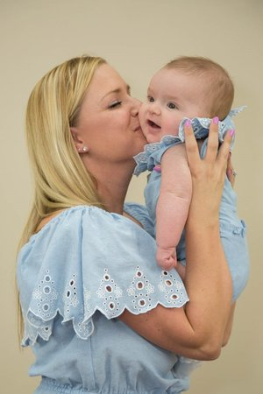
“The guys in my office really took care of me throughout my pregnancy. They had never employed a pregnant woman before, so there was obviously no maternity plan in place. Phill kind of just asked what I needed and then he made it happen. I was so fortunate to have him as my boss. To this day, I never worry about balancing motherhood and work. I know that if my daughter needs me, I can go to her, no questions asked. If I continue to work hard and show results in my work, Phill allows me to adjust my schedule as needed. It is a dream job for a mom who values motherhood but also wants to keep her professional goals on track.”
Cecelia maintains a standard work schedule but enjoys the times she can work with her daughter by her side.
“I work from home two days a week and those are my favorite days. I think any mom would say daycare is not ideal, but you do what you got to do. When I work from home, I feel like I can teach my daughter first hand the importance of a good work ethic. She certainly doesn’t understand any of this now, because she is only 5 months old, but one day she will. It is important to me that she values work and grows up knowing what good work ethic is. Who knows, maybe one day we will even work together in this office. I would love for her to become an engineer!”
We can not say enough about the amazing women in our office.
So, to our wonderful working moms, and all the working moms out there, Happy Mother’s Day!

